# Chapter 10 Managing Conflict and Negotiations

The Organizing Framework in Figure 10.1 summarizes the key concepts you’ll learn in this chapter. You’ll notice a large number of person factors, such as your personality, experience, conflict-handling styles, mindfulness, and civility influence the type, frequency, and intensity of conflict you have in all arenas of your life. Many of these same factors influence how you negotiate. You’ve also undoubtedly expect relationship quality, leadership, organizational climate, as well as a number of norms and practices to shape conflict and negotiations at work. The importance of these factors notwithstanding, our primary focus in this chapter is understanding conflict and negotiation processes themselves, and how they in turn impact nearly every outcome in the Organizing Framework. This complexity and broad impact of conflict, in particular, highlights the critical importance of managing conflict for your own satisfaction and performance at work.

Winning at Work,

Negotiating Salaries and Raises,

Experts offer this advice for getting the best compensation you can.

Negotiating Your Salary for a New Job,

Know the market rate. Research what companies are paying other employees with similar jobs in the same area. Glassdoor.com often can help.

Know your own value. Can you justify asking for more than the market rate? If yes, then be prepared to justify this premium with compelling examples of your performance and accomplishments. Whether asking for premium or not, it is always a good idea to focus on how you benefited your past or present employers.

What’s in it for them? Of course, like everybody else you pursue particular jobs because of how they will benefit you. However, during interviews and negotiations for a new job you are best served by focusing on the ways you can benefit your new employer, help the hiring manager reach her goals, and what a positive impact you’ll have in work teams.

Be honest. Don’t exaggerate your current or past pay, your actual value, or accomplishments.

Don’t go first. Try to wait for the other person to name a number. If you feel you must say something first, then you might say you want to be paid the rate of a top performer with your qualifications. If you have to give an answer, give a range, not a specific dollar figure.

Consider benefits, too. Some of the most valuable parts of your compensation package may be insurance, retirement savings, vacation time, or the ability to work from home a certain percentage of time. Retirement may seem like eons away, but an employer matching your 5 percent contribution to your 401 k plan is like giving you an extra 5 percent of pay, ‘without an immediate tax bite.

Look at the long term. If you can’t get a big pay package, consider whether you can ask for something else that will help your long-term career, for example, a chance to work on an important assignment.

Negotiating a Pay Raise,

Preparation is critical. You need information, and the following are some valuable sources and techniques for acquiring it.

Ask current colleagues. Peers are the best but also the toughest source. The best strategy is to be honest and say: I’m not sure my salary reflects market value, so I’m checking with colleagues to find out what the current salary range is in our field. Would you be willing to talk about compensation? Assure them you’ll keep it confidential, and then, if they’re willing, start by giving them a range where your salary falls and asking them how it compares with theirs.

Query former colleagues. Ask former coworkers what they think is an appropriate range for your job in a company of your employer’s size and industry. It may help to keep the discussion in the third person: What do you think is a competitive or appropriate salary for a solid performer doing X type of work in a company like mine or a company like yours ?

Give to get. Another effective approach is to offer your salary and then ask: Does that sound competitive with what you’re making or what your company offers?

Ask recruiters. One of the very best sources is recruiters who place people in jobs and companies like yours. Salary is almost always part of their discussions. So, if you’re going to build out your network, adding a recruiter or two who will share such info can be extremely valuable. But you need the relationship first. It’s no use cold calling a recruiter and expecting him or her to answer your questions, ‘that expertise is part of what recruiters get paid for!2

What’s Ahead in This Chapter,

We continue our discussion of the group and team level in the Organizing Framework and address conflict and negotiation in this chapter. Conflict is an inevitable part of organizational life. We describe both positive and negative forms of conflict, ‘yes, there are both. We also explore common forms of conflict at work, such as personality and intergroup. Significant attention is given to work life conflict and cyberbullying, problems created and intensified by Internet technology and social media. We then provide practical guidance on how to manage various forms of conflict, followed by an explanation of negotiation, including types of negotiations and ethical pitfalls.

## 10.1 A Contemporary View of Conflict,

MAJOR QUESTION,

How can a contemporary perspective on conflict make me more effective at school, work, and home?

The Bigger Picture,

Conflict is an ever-present part of your life and an important group-level process in the Organizing Framework. To help you better understand and manage conflict, we explore several common causes of conflict at school and work. Then you’ll learn about what it means to have too little, too much, and just enough conflict the conflict continuum . We explain why not all conflict is bad or dysfunctional; some forms are functional or desirable. Next, we describe some desired outcomes of functional conflict.

Because conflicts occur between people, a good place to begin is for you to learn about your own tendencies for conflicts with others. You likely believe you have relatively few and are easy to get along with, which may be true. However, even the most problematic bosses think so of themselves. Test your impressions of yourself by completing Self-Assessment 10.1

Conflict Is Everywhere and It Matters,

Conflict is a pervasive part of the human experience. Some surveys report that employees spend two or more hours per week, or one day per month, dealing with some type of conflict at work. Not only is conflict time consuming, but employees also report many other undesirable consequences, such as:

25 percent call in sick.

24 percent avoid work related events.

18 percent quit.

16 percent say they’ve been fired.

9 percent attribute project failures to conflict.

Whether these statistics move you or not, you can safely assume that all forms of conflict at work are underreported. Due to these consequences, and the fact that conflict occurs both within and between levels in the Organizing Framework for OB, managing it effectively is essential for individual, departmental, and organizational effectiveness.

A Modern View of Conflict,

Conflict occurs when one , party perceives that its interests are being opposed or negatively affected by another party., The word perceives reminds us that sources of conflict and issues can be real or imagined, just like perceptions of fairness. A lack of fairness, perceived or real, is a major source of conflict at work.

A Conflict Continuum,

Ideas about managing conflict underwent an interesting evolution during the 20th century. Initially, management experts believed all conflict ultimately threatened management’s authority, reduced productivity, and thus had to be avoided or quickly resolved. They later recognized the inevitability of conflict and advised managers to learn to live with it. Emphasis, nevertheless, remained on resolving conflict whenever possible. Beginning in the 1970s, OB specialists realized conflict had both positive and negative outcomes. This perspective introduced the revolutionary idea that organizations can suffer from either too much conflict or too little. Neither is desirable.

Appropriate types and levels of conflict energize people to move in constructive directions. The relationship between conflict intensity and outcomes is illustrated in Figure 10.2. The differences between types and levels of conflict lead to the distinction between functional and dysfunctional conflict discussed next.

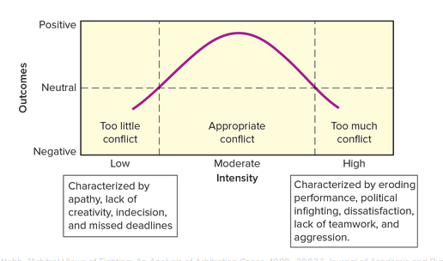

Functional vs. Dysfunctional Conflict,

The distinction between functional conflict and dysfunctional conflict pivots on whether the organization’s interests are being served. Functional conflict, commonly referred to as constructive or cooperative conflict, is characterized by consultative interactions, a focus on the issues, mutual respect, and useful give and take. In such situations people often feel comfortable disagreeing and presenting opposing views. Positive outcomes frequently result.

Each of these factors is lacking in cases of dysfunctional conflict, disagreements that threaten or diminish an organization’s interests. This danger highlights the valuable role of management, and your own actions, in determining whether conflict is positive. To effectively deal with any kind of conflict, we need to understand some of the common causes.

Common Causes of Conflict,

Certain situations produce more conflict than others. Knowing the causes can help you and managers anticipate conflict and take steps to resolve it if it becomes dysfunctional. Table 10.1 lists many of the situations that tend to produce either functional or dysfunctional conflict.

Table 10.1 SITUATIONS THAT COMMONLY PRODUCE CONFLICT

Incompatible personalities or value systems ,

Inadequate communication, Overlapping or unclear job boundaries, Interdepartment/intergroup competition, Competition for limited resources, Unreasonable deadlines or extreme time pressure, Unreasonable or unclear policies, standards, or rules, Decision making by consensus dissenters may feel coerced , Organizational complexity conflict tends to increase as the number of hierarchical layers and specialized tasks increases , Collective decision making the greater the number of people participating in a decision, the greater the potential for conflict , Interdependent tasks one person cannot complete his or her assignment until others have completed their work , Unmet expectations employees who have unrealistic expectations about job assignments, pay, or promotions are more prone to conflict

Which have happened to you?

Escalation of Conflict,

When conflict escalates, the intensity increases and often leads to cycles of provocation and counter provocation. The conflicting parties then often replace meaningful exchange and debate with increasingly destructive and negative attacks, which are often more about undermining or hurting the other party than advancing one’s own interests. People then take positions that are increasingly extreme and hard to justify. Conflict escalation often exhibits these five characteristics:

1. Tactics change. Parties often move from , light tactics, such as persuasive arguments, promises, and efforts to please the other side, to , heavy tactics, that include threats, power plays, and even violence.
2. Number of issues grows. More issues that bother each party are raised and included in the conflict.
3. Issues move from specific to general. Small and specific concerns often become more vague or general and can evolve into a general dislike of or intolerance for the other party.
4. Number of parties grows. More people and groups are drawn into the conflict.
5. Goals change. Parties change their focus from , doing well, or resolving conflict to winning and even hurting the other party.

Why People Avoid Conflict,

Are you uncomfortable with conflict? Do you go out of your way to avoid it? If so, you’re not alone. Many of us avoid conflict for a variety of reasons both good and bad. Some of the most common are the following:

Fear of harm to ourselves.

Fear of rejection.

Fear of damage to or loss of relationships.

Anger.

Desire not to be seen as selfish.

Desire to avoid saying the wrong thing.

Fear of failure.

Fear of hurting someone else.

Fear of getting what you want.

This list is self explanatory, except for the last item. It refers to people who, for personal reasons, feel undeserving or fear the consequences of success and thus tend to sabotage themselves.

Of course, avoiding conflict doesn’t make it go away. It may continue or even escalate. Moreover, avoiding conflict can cost you a promotion. Many otherwise qualified employees are passed over for management and executive positions because they avoid making tough decisions, confronting poor performance, or challenging weak or faulty ideas. This suggests that conflict handling, not conflict avoiding, skills are in high demand. Southwest Airlines took this to heart.

Leaders wanted to shake up what they viewed as a culture of artificial harmony among staffers. The company now promotes middle managers to executive positions partly based on their ability to spark conflict among staffers, says Elizabeth Bryant, vice president of training. During a five-week training program, these high-potential managers learn to foster vigorous but respectful internal debates.

Avoiding Conflict Makes It Grow,

When you’re tempted to avoid conflict, you may be wise to do the following instead.

Stop ignoring a conflict. Ignoring or working around a conflict won’t make it go away and may cause further escalation. Instead, bring both sides together to address the issues.

Act decisively to improve the outcome. Delay only causes the problem, real or perceived, to fester. Addressing a conflict in short order can help unveil misunderstandings or simple oversights before they grow into something more or spread.

Make the path to resolution open and honest. Involve all relevant parties, collect information, and determine a desired outcome. Doing so helps resolve misunderstandings and focuses everybody on the end state instead of wallowing in the alleged offenses.

Use descriptive language instead of evaluative. Beware of accusations and judgmental language. Both put people on the defensive and impede progress. Instead, focus on the problem behaviors, feelings, implications and solution rather than the perpetrator.

Make the process a team-building opportunity. If the problem affects the team, then it may be beneficial to approach the conflict and its solution as a team. Such resolutions may improve relationships in such a way that the team functions even better than it did before the conflict.

Keep the upside in mind. Effective conflict resolution creates success momentum. In other words, conflicts are signs along the road to the final and desired destination. Don’t get bogged down and lose sight of the ultimate goal or bigger picture.

What is the alternative? The Applying OB box below provides useful suggestions. For our purposes, it is enough to become aware of our fears and practice overcoming them, as the rest of this chapter will show.

Desired Outcomes of Conflict Management,

Conflict management is more than simply a quest for agreement, nor should it be a quest for victory. If progress is to be made and dysfunctional conflict minimized, we need a broader goal. An influential model of cooperative conflict outlines these three desired outcomes:

Agreement. Equitable and fair agreements are best. An agreement that leaves one party feeling exploited or defeated will tend to breed resentment and subsequent conflict.

Stronger relationships. Good agreements enable conflicting parties to build bridges of goodwill and trust for future use. Moreover, conflicting parties who trust each other are more likely to keep their end of the bargain they have made.

Learning. Functional conflict can promote greater self awareness and creative problem solving.

We therefore encourage you, when possible, to look at conflict not as a war or a battle, but instead as an opportunity or a journey. Keep the following observation in mind for the balance of this chapter:

Conflict gives you an opportunity to deepen your capacity for empathy and intimacy with your opponent. Your anger transforms the other into a stereotyped demon or villain. Similarly, defensiveness will prevent you from communicating openly with your opponents, or listening carefully to what they are saying. On the other hand, once you engage in dialogue with that person, you will resurrect the human side of his/her personality, ‘and express your own as well.

## 10.2 Conventional Forms of Conflict,

MAJOR QUESTION

What are some types of conflict and how can I manage them to my benefit?

The Bigger Picture,

You can probably think of many types of conflicts from your own life, and you likely have a good idea what caused most of them. But in this section we focus on two of the most common and consequential types of conflict in organizations, ‘personality and intergroup. The first occurs at the individual level and the other at the group level. Understanding both types will make you more effective at managing an extremely valuable group-level process in the Organizing Framework.

As we discussed in the first section, opposition isn’t necessarily a problem. It can be a constructive way of challenging the status quo and improving behaviors, processes, and outcomes. New ideas by definition contrast with old ideas or ways of doing things. However, opposition becomes an issue if it turns into dysfunctional conflict and impedes progress and performance. Personality conflict and intergroup conflict can both cause a number of undesirable outcomes across levels of the Organizing Framework for OB.

Personality Conflicts,

Given the many possible combinations of personality traits, it is clear why personality conflicts are inevitable. How many times have you said or heard, I just don’t like him [or her]. We don’t get along., One of the many reasons for these feelings and statements is personality conflicts. We define a personality conflict as interpersonal opposition based on personal dislike or disagreement. Like other conflicts, personality conflicts often escalate if not addressed. Think of personality conflicts you’ve had at work or school. What were the consequences for you? The other person? Members of your team, department, or class? Did they escalate? If the source of a conflict really is personalities, it is particularly troublesome since personality traits are by definition stable and resistant to change.

Research shows that conflicts over work tasks can turn into personal conflicts and escalate into bullying. But they have other undesirable outcomes too, such as negative emotions related to particular coworkers and to work in general. If these feelings persist beyond work, employees can ruminate and fail to recover appropriately. The result can harm their health and non-work relationships.

Bill Gross is the billionaire investor long known as the bond king. Beginning in the early 1970s he worked at PIMCO and built a $2 trillion empire. His stern, domineering, my way or the highway approach caused many conflicts. But in recent years these conflicts with noted individuals within the firm, including then-CEO Mohammed El-Erian, became intolerable. El-Erian and others left, and Gross tried to fire more. Eventually the board fired Gross. The troubles didn’t stop there. Investors have pulled nearly $400 billion since Gross’s departure, and he is suing PIMCO for $200 million more. He now works just down the street at a competitor, ‘Janus.

A particularly troublesome form of conflict that is too often attributed to personalities is sexual harassment and other forms of discrimination. Such conflicts have nothing to do with personalities and are unethical if not also illegal. But the accused often attribute the target’s resistance and complaints to personality: She’s too sensitive, or He can’t take a joke. It is critically important to identify and remedy such conflicts.

How to Deal with Personality Conflicts,

OB in Action

The CEO Who Planned a Food Fight,

Kevin Reddy, the chair and CEO of Noodles & Co. Restaurants and former COO of Chipotle Mexican Grill, hired Dan Fogarty as chief marketing officer knowing Fogarty’s personality clashed with that of the company’s president, Keith Kinsey. Fogarty and Kinsey had previously worked together at Chipotle.

Reddy knew that Kinsey was analytical and pragmatic, while Fogarty was unstructured and creative. The CEO counted on and took advantage of their different personalities and heated debates. Reddy believed executives who challenge one another, ‘rather than validating each others’ ideas, ‘produced the best thinking. He said, I don’t mind if it gets a little bloody as long as it’s merely a flesh wound.

Table 10.2 How to Respond When an Employee Experiences a Personality Conflict

Butt Your Heads Together and Fix the Problem,

At Black Butte Coal in Wyoming, a warehouse supervisor and maintenance manager’s conflict escalated to the point that their manager was going to fire both of them. Not only did they disagree and argue, but they also yelled at each other in front of other employees. It seemed that their goals for their respective departments, and the determination of each to meet those goals at the other’s cost, caused them to lose sight of the bigger picture and the way their efforts contributed to the outcome for the larger company.

Amanda DeBernardi, the HR manager, stepped in to help. She put the two employees in a room with a blank piece of paper in front of each. She then gave each the opportunity to explain his position and issues, without interruption, while the other took notes.

Apply the 3-Step Problem-Solving Approach,

Step 1:Define the problem in this case. Step 2:Identify the potential causes. Step 3:Make your recommendations. DeBernardi got you started on a potential solution, but what else would you do? You can build on her actions or take a different course. Explain.

How successful his strategy proved is hard to say. But it is worth noting that in 2015 Fogarty left in March, citing personal reasons, 22 and Kinsey left in June to become CEO of Portillo’s Hot Dogs.

Table 10.2 presents practical tips for both you and managers who are involved in or affected by personality conflicts. Best practices vary depending on the party. Steps 2 through 4 in the table show how to escalate your concern if the conflict is not resolved.

FOR THE EMPLOYEE, Be familiar with and follow company policies on diversity, discrimination, and sexual harassment.

FOR THE EMPLOYEE, Communicate directly with the other person to resolve the perceived conflict emphasize problem solving and common objectives, not personalities .

FOR THIRD PARTY OBSERVERS, Do not take sides in someone else’s personality conflict.

FOR THE EMPLOYEE’S MANAGER, Investigate and document the conflict; if appropriate, take corrective action feedback or behavior modification .

FOR THE EMPLOYEE, Avoid dragging coworkers into the conflict.

FOR THIRD PARTY OBSERVERS, Suggest the parties work things out for themselves in a constructive and positive way.

FOR THE EMPLOYEE’S MANAGER, If necessary, attempt informal dispute resolution.

FOR THE EMPLOYEE, If dysfunctional conflict persists, seek help from direct supervisors or human resource specialists.

FOR THIRD PARTY OBSERVERS, If dysfunctional conflict persists, refer the problem to the parties’ direct supervisors.

FOR THE EMPLOYEE’S MANAGER, Refer difficult conflicts to human resource specialists or hired counselors for formal resolution efforts and other interventions.

Intergroup Conflict,

Conflict among work groups, teams, and departments is a common threat to individual and organizational effectiveness, as illustrated in the Organizing Framework. The application of hydraulic fracturing fracking to extract oil, for instance, has caused intense conflicts between local residents, local and state legislatures, energy companies, and environmental groups. In Florida, environmentalists are against fracking, local governments and citizens are concerned about damage being done in their communities, oil companies are eager to drill, and all these concerns roll up to the state legislature, which must ultimately decide what to do. In early 2016 the state considered legislation that would regulate fracking. The other parties then argued that the measures the state is considering miss important elements and potential consequences.

Conflict States and Processes,

Conflict states are shared perceptions among team members about the target and intensity of the conflict. Targets can be either tasks goals or ideas or relationships.

Conflict processes are the means by which team members work through task and relationship disagreements.

In Group Thinking, Us vs. Them,

Cohesiveness, a, we feeling, that binds group members together, can be a good thing or a bad thing. A certain amount of cohesiveness can turn a group of individuals into a smooth running team. Too much cohesiveness, however, can breed groupthink, because a desire to get along pushes aside critical thinking and challenges to existing or inferior ideas. The study of in groups has revealed an array of challenges associated with increased group cohesiveness and in group thinking.

Specifically, members of in groups view themselves as a collection of unique individuals, while they stereotype members of other groups as being , all alike.,

In group members see themselves positively and as morally correct, while they view members of other groups negatively and as immoral.

In groups view outsiders as a threat.

In group members exaggerate the differences between their group and other groups, which typically leads them to a distorted perception of reality.

How to Handle Intergroup Conflict,

How have you attempted to solve conflicts between a group of which you are a member and another group? While many techniques are successful in particular situations, research and practice support three specific approaches:

1. Contact hypothesis.
2. Conflict reduction.
3. The creation of psychologically safe climates.

Contact Hypothesis,

The contact hypothesis suggests that the more members of different groups interact, the less intergroup conflict they will experience. Those interested in improving race, international, and union management relations typically encourage cross group interaction. The hope is that any type of interaction, short of actual conflict, will reduce stereotyping and combat in group thinking.

But research has shown this approach to be naive and limited. For example, a study of ethnic majority in group and ethnic minority out group students from Germany, Belgium, and England revealed that contact did reduce prejudice. Specifically, contact over time resulted in a lower desire for social distance and fewer negative emotions related to the out group. The quality of contacts mattered too, especially regarding equal status, cooperation, and closeness. It wasn’t enough simply to encounter members of the out group to just be introduced, for example .

However, prejudice also reduced contact. Those in the out group were more reluctant to engage with or contact the in group. Contact had no effect on reducing prejudice of the minority out group toward the majority in group. One interpretation of these results is that contact matters, high quality contact matters more, but both matter the most from the in group’s perspective.

Nevertheless, intergroup friendships are still desirable, as many studies document. But they are readily overpowered by negative intergroup interactions. Thus the top priority for managers faced with intergroup conflict is to identify and root out specific negative linkages between or among groups. More specifically, focusing on the perceived security and quality of the interactions matters. If you and/or your managers can make the out group feel there is nothing at stake they are not being evaluated , they are more likely to feel secure and satisfied with the interaction. This reassurance can also reduce both groups’ prejudices about the other. We can achieve such benefits by sharing social interests or social events where the focus is not on work, particularly the out group’s work.

Conflict Reduction,

Considering this evidence, managers are wise to note negative interactions between members and groups and consider options for reducing conflict. Several actions are recommended:

Eliminate specific negative interactions obvious enough .

Conduct team building to reduce intra group conflict and prepare for cross functional teamwork.

Encourage and facilitate friendships via social events happy hours, sports leagues, and book clubs .

Foster positive attitudes empathy and compassion .

Avoid or neutralize negative gossip.

Practice the above, be a role model.

Creating a Psychologically Safe Climate,

As we’ve discussed, conflict occurs at all levels in the Organizing Framework. This means the causes and remedies can also occur at individual, group, and organizational levels. One such organizational level cause and remedy is a climate of psychological safety. A psychological safety climate represents a shared belief among team members that it is safe to engage in risky behaviors, such as questioning current practices without retribution or negative consequences. When employees feel psychologically safe, they are more likely to speak up and present their ideas and less likely to take disagreements personally. This interaction results in increased team creativity, less conflict within and between teams, and higher individual and team performance. Psychological safety climates also help improve employee turnover, safe work behaviors, and job satisfaction.

How can you and your employers create or foster a climate for psychological safety? Here are three fundamental and widely applicable practices:

1. Ensure leaders are inclusive and accessible.
2. Hire and develop employees who are comfortable expressing their own ideas, and receptive and constructive to those expressed by others.
3. Celebrate and even reinforce the value of differences between group members and their idea.

## 10.3 Forms of Conflict Intensified by Technology

MAJOR QUESTION,

What can I do to manage work family conflict and incivility to make me more effective at school, work, and home?

The Bigger Picture,

We focus our discussion on two particular forms of conflict: work family conflict and incivility. You face demands at school and other arenas of your life, ‘work, social life, and perhaps a family, ‘and these demands can compete with each other and cause conflicts for you. Such conflicts, along with uncivil behavior or mistreatment, can have dramatic and undesirable effects on your personal health, well-being, opportunities, and other outcomes in the Organizing Framework.

Students, employees, and people everywhere have always experienced conflicts between the various arenas of their lives, notably between work, school, and home. But historically, various activities and their demands were confined to the physical locations in which they occurred, ‘work happened largely at the office. Not anymore. Technology has blurred the old boundaries, ‘and also extended mistreatment to every place and every arena. The Internet and social media are new and devastating tools for bullies and other bad actors. For these reasons we give special attention to these forms of conflict.

Work Family Conflict,

Work family conflict occurs when the demands or pressures from work and family domains are mutually incompatible. Work family conflict can take two distinct forms: work interference with family and family interference with work. For example, suppose two managers in the same department have daughters playing on the same soccer team. One manager misses the big soccer game to attend a last minute department meeting work interferes with family , while the other manager skips the meeting to attend the game family interferes with work . Both kinds of conflicts matter, because they can negatively affect many important outcomes in the Organizing Framework and your larger life domain see Table 10.3 . As research accumulates, it is also becoming clear that work interfering with family is the far more frequent and consequential problem.

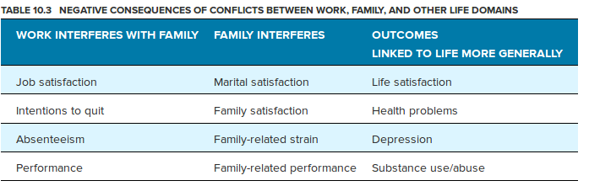

Making many conflicts worse is the spillover effect. This means, for instance, that hostilities in one life domain can manifest in other domains. Because these and other consequences can be numerous and troublesome, researchers and managers alike have devoted extensive attention and effort to understanding and reducing conflicts and their spillover effects. From a practical perspective, it is helpful to think of balance.

Balance Is the Key to Reducing Conflict,

A survey asked employees to list the biggest factors that damage work–life balance:

The leading answer by a mile was bad bosses defined as demanding, overbearing, and mean. Tied for second, constantly working beyond standard business hours and inflexibility in scheduling work hours and off time. A not-so-distant third were incompetent colleagues and long commute.

It is therefore no surprise that 46 percent of employees in another survey said work life balance was the thing they valued most when looking for a new job second only to salary, cited by 57 percent . Ideally, you will be able to avoid or remove conflicts completely. But more often than not you will have to balance demands coming from the different domains of your life. Here are some ideas to consider.

1. Work family balance begins at home. Case studies of successful executives reveal that family and spousal support is critical for reaching senior level positions. This suggests that both men and women need help with domestic responsibilities if there is any chance of achieving work family balance.
2. An employer’s family supportive philosophy is more important than specific programs. Organizational culture must support the use of family friendly programs in order for employees to benefit from them. For instance, it’s not enough to simply provide child care; employees must also feel supported and comfortable using it. The same goes for leaving work early to attend a child’s sporting event or recital.
3. The importance of work family balance varies across generations. A study of the work values of 16,000 adults of all ages suggests that organizations should consider implementing work policies targeted toward different generational groups. For example, flextime and compressed work programs can attract and retain both Gen Ys and Gen Xers, while job enrichment may be a more effective way to motivate baby boomers.

Sheryl Sandberg, chief operating officer of Facebook, moved the issue of work–life balance to the front pages with her celebrity and her book Lean In. She championed the belief that women can have it all, including rising to the C-suite in corporate America. But having it all, according to Sandberg, requires a husband or partner who can help balance the load. In her own book, Unfinished Business, Anne-Marie Slaughter, former Princeton dean and State Department official, agrees with Sandberg that women can indeed climb to the top rungs of corporate ladders. However, she claims that women can’t have it all unless they are superhuman, rich, or self-employed. The system needs to change men need to have the same responsibilities as women and vice versa in order for there to be balance and for the career trajectories of women to be similar to those of men.

OB in Action,

At United Shore Financial, ‘Give Me Only 40 or You’re Fired!

A number of companies have taken work life balance to another level. For instance, United Shore Financial Services in Troy, Michigan, requires that employees work only 40 hours per week. Sure, plenty of companies talk about such limits, but it’s a reality at this mortgage wholesaler. Mat Ishbia, the CEO, claims the firm 40 policy makes employees more efficient and focused when at work, knowing they must be completely unplugged when they leave. There is no after-hours e-mailing or coming in on weekends.

Ishbia also claims that since word about the policy has gotten out, the firm has attracted more talented employees than in the past. He describes the policy this way: 5:55 p.m. on a Friday is no different from 10:55 a.m. on a Tuesday, ‘taking no breaks for Facebook or online shopping. But once the day is done, employees are off duty until the next morning. Laura Lawson, the company’s chief people officer, says this: You give us 40. Everything else is yours. The premise, supported by research, is that everybody needs time to recover. More hours do not necessarily translate into more productivity. Some studies in fact show that any more than 48 hours of work per week results in a dramatic decrease in productivity per hour.

United Shore’s practices are quite different from those of many companies trying to better integrate work and life and in the process often further blurring the lines between these two arenas and increasing conflict.

Flex Space vs. Flextime and Your Supervisor,

Flex space, such as telecommuting, occurs when policies enable employees to do their work from different locations besides the office coffee shops, home, or the beach .

Flextime is flexible scheduling, covering either the time when work must be completed deadlines or the limits of the workday 9 to 5, 10 4, or any time today .

Understanding the differences can help you better balance your own demands between not only work and family, but school and the rest of your life too. At first you might think more is better more flex space and more flextime will make you happier if not also more productive. Research shows that this is not true. There can be benefits to greater flexibility, but flex space in particular can end up further blurring the boundaries between work and other arenas of your life and consequently adding to conflicts. Flex, but beware.

One final caution: The value of most flexible work arrangements can be undermined if your immediate supervisor isn’t supportive. Put another way, supportive policies matter, but what good is a policy if you aren’t allowed to use it? Fully half of companies surveyed offer some sort of flexible work arrangements, yet the same companies report that only a third of employees utilize them.

Incivility, Treating Others Poorly Has Real Costs,

Incivility is any form of socially harmful behavior, such as aggression, interpersonal deviance, social undermining, interactional injustice, harassment, abusive supervision, and bullying. Like other OB concepts, incivility is perceptual, it is in the eyes of the beholder. If you feel you’ve been treated poorly, then you’ve been treated poorly, and this feeling is what affects numerous outcomes across levels of the Organizing Framework.

Causes of Incivility,

It’s no surprise that both individuals and their employers can be the root cause of mistreatment at work. Figure 10.3 illustrates common causes of various forms of incivility.

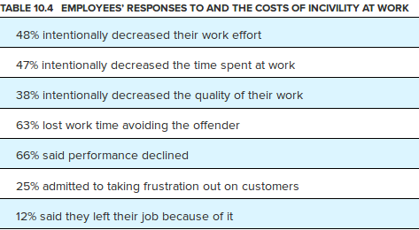

Recent research reports that 98 percent of employees reported experiencing some form of incivility, and 50 percent said they had been treated rudely at least once a week! Table 10.4 describes common employee responses to incivility and their frequencies. Besides the obvious, that no one likes to be mistreated, experts on the topic describe the costs of incivility this way:

Note that the causes, just like the outcomes, can occur at all three levels in the Organizing Framework. Also note that incivility is contagious, like emotions, and if unchecked it can escalate. If your boss is rude to you, then you are more likely to look for rude behavior in your interactions with others and respond accordingly negatively. This may help explain why incivility has been shown to be catastrophic to teamwork, because it undermines collaboration and individual member performance. This means bad behavior is truly an organizational problem, even if it starts with a single individual.

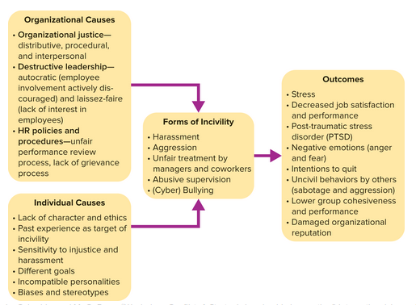

Bullying,

Bullying occurs at multiple levels in OB. Recall our discussion of counterproductive work behaviors and bullying in Chapter 2, where the Winning at Work section and a Problem Solving Application box addressed bullying from the target’s or individual’s perspective. We build on these here and explore the implications of bullying at the group and organization levels. Bullying is different from other forms of mistreatment or incivility in at least three ways.

1. Bullying is usually evident to others. Bullies at work don’t have to push you down or take your lunch money, like they do in elementary school. But even when the bullying is less obvious and nonviolent, coworkers are commonly aware through either gossip or other forms of communication meetings, e mail, and social media that someone is being bullied.
2. Bullying affects even those who are NOT bullied. Research shows that employees who are simply aware of bullying of colleagues but are not themselves a target are more likely to quit their jobs. This means bullying has costs that extend well beyond the harm to the person being bullied. Simply witnessing or being aware that one of your colleagues is mistreated has negative effects on you.
3. Bullying has group level implications.

Cyber Bullying and Harassment. Because even those who are not targeted by bullies can be affected, bullying often negatively affects group dynamics and group satisfaction and performance, important processes and outcomes in the Organizing Framework.

Advances in technology have changed the nature of conflict at school and work. The Internet and particularly social media have created new avenues and weapons for bullies at school, at work, and in our social lives. Many researchers now report that virtual bullying is more common than face to face bullying, although the two often co-occur. Worse still, both face to face and cyber bullying affect their victims in two ways. Not only do the uncivil acts directly harm the targeted person, but also the fear of future mistreatment amplifies this effect. Given this, what can you and managers do to avoid bullying and other forms of incivility? The practices described in Table 10.5 are a good start. But it is useful for you and your employer to take specific actions to prevent and address virtual incivility harassment and bullying in e mails and social media. Here are some ideas.

Policies,

Create and enforce policies covering acceptable technology usage.

Ensure that company technology computers and smartphones cannot be used anonymously.

Communicate expectations for e mail and social media communications outside work that affect the organization and its members.

Practices,

Enforce your policies!

In communications, be wary of:

The use of bold or UPPER CASE lettering denoting shouting and underlining and punctuation.

Messages that are mean spirited.

Demeaning phrases.

Personal insults.

Avoid sending copies of e mails related to conflicts to people who don’t need to be involved, so as not to embarrass the recipient or escalate the conflict.

Think before you hit the send button it’s a good idea to wait until the next day .

Take appropriate action when you become aware of , conflict producing, e mail.

Another way to be more effective and helpful when witnessing bullying is to take the perspective of the target. Consciously think about what it is like to be him or her, walk in his or her shoes, and experience the effects of being bullied. In a practical sense, perspective-taking can serve as a low-cost and highly effective intervention to help reduce many of the prejudices and bad behaviors often observed in work and school settings. You can also use it when mediating conflicts, because in the heat of the conflict most parties are so focused on themselves that they never think to consider the other’s view.

Remember that mistreatment has more victims than the actual target. Don’t be a silent bystander, but do your part to prevent and remedy various forms of incivility at school, work, and home.

## 10.4 Effectively Managing Conflict

MAJOR QUESTION,

What can I do to prevent, reduce, or even overcome conflict?

The Bigger Picture,

We extend your knowledge in this section by introducing a number of practical means for dealing with a variety of conflicts. Specifically, we explore ways to program or create functional conflict. You also will learn about various conflict-handling styles and when to use them. We then explore how to implement alternative forms of dispute resolution ADR . The practical knowledge in this section will enable you to better manage conflicts and in turn yield many important outcomes in the Organizing Framework.

Programming Functional Conflict,

Have you ever been on a team or committee that got so bogged down in details and procedures it accomplished nothing? Most of us have. Such experiences are both a waste of time and frustrating. To break out of such ruts, you essentially have two options:

1. Fan the fire and get more of the same. Managers can urge coworkers to hunker down and slog through, ‘simply persist. While this approach may work, it can be unreliable conflict can escalate and slow.
2. Program conflict. Managers can resort to programmed conflict. Experts in the field define programmed conflict as, conflict that raises different opinions regardless of the personal feelings of the managers., The challenge is to get contributors to either defend or criticize ideas based on relevant facts rather than on the basis of personal preference or political interests. This positive result requires disciplined role playing and effective leadership.

Two programmed conflict techniques with proven track records are devil’s advocacy and the dialectic method. Let’s explore each.

Devil’s Advocacy,

Devil's advocacy gets its name from a traditional practice within the Roman Catholic Church. When someone’s name comes before the College of Cardinals for elevation to sainthood, it is absolutely essential to ensure that the person had a spotless record. Consequently, one individual is assigned the role of devil’s advocate to uncover and air all possible objections to the person’s canonization. In today’s organizations devil’s advocacy assigns someone the role of critic. Figure 10.4 shows the steps in this approach. Note how devil’s advocacy alters the usual decision-making process in steps 2 and 3 on the left-hand side of the figure.

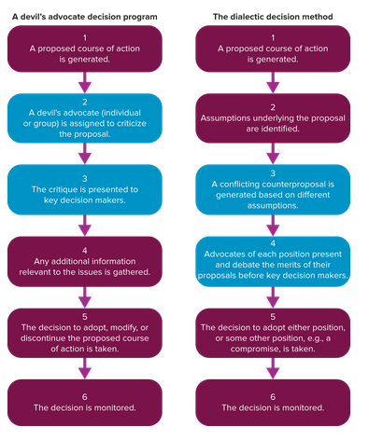

The Dialectic Method,

Like devil’s advocacy, the dialectic method is a time honored practice, going all the way back to ancient Greece. Plato and his followers attempted to identify truths, called thesis, by exploring opposite positions, called antithesis. Court systems in the United States and elsewhere today rely on hearing directly opposing points of view to establish guilt or innocence. Accordingly, the dialectic method calls for managers to foster a structured dialogue or debate of opposing viewpoints prior to making a decision. Steps 3 and 4 in the right hand side of Figure 10.4 set the dialectic approach apart from common decision making processes.

Pros, Cons, and Practical Advice on Programmed Conflict,

It is a good idea to rotate the job of devil’s advocate so no one person or group develops an undeserved negative reputation. Moreover, periodically playing the devil’s advocacy role is good training for developing analytical and communication skills and emotional intelligence.

As for the dialectic method, it is intended to generate critical thinking and reality testing. A major drawback is that the goal of, winning the debate, might overshadow the issue at hand. The dialectic method also requires more skilled training than does devil’s advocacy. Research on the relative effectiveness of the two methods ended in a tie, although both methods were more effective than consensus decision making. However, another study showed that devil’s advocacy produced more potential solutions and made better recommendations for a case problem than did the dialectic method.

Conflict Handling Styles,

People tend to handle negative conflict in similar ways, referred to as styles. Figure 10.5 shows that five of the most common styles are distinguished by the combatants’ relative concern for others x axis and for self y axis . The combinations of these two characteristics produce the conflict handling styles called integrating, obliging, dominating, avoiding, and compromising.

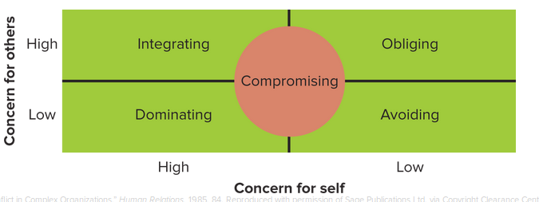

When to Apply the Various Conflict Handling Styles,

Consistent with the contingency approach described throughout this book, conflict resolution has no, one style fits all, approach. Research and practice thankfully provide some guidance indicating which styles seem to work best in particular situations see Table 10.6,

STYLE Integrating APPROPRIATE:

Issues are complex.

Synthesis of ideas is needed to come up with better solutions.

Commitment is needed from other parties for successful implementation.

Time is available for problem solving.

One party alone cannot solve the problem.

Resources possessed by different parties are needed to solve their common problem.

STYLE Integrating INAPPROPRIATE:

Task or problem is simple.

Immediate decision is required.

Other parties are unconcerned about outcome.

Other parties do not have problem solving skills.

STYLE Obliging APPROPRIATE,

You believe that you may be wrong.

Issue is more important to the other party.

You are willing to give up something in exchange for something from the other party in the future.

You are dealing from a position of weakness.

Preserving relationship is important.

STYLE Obliging INAPPROPRIATE,

Issue is important to you.

You believe that you are right.

The other party is wrong or unethical.

STYLE Dominating APPROPRIATE,

Issue is trivial.

Speedy decision is needed.

Unpopular course of action is implemented.

Necessary to overcome assertive subordinates.

Unfavorable decision by the other party may be costly to you.

Subordinates lack expertise to make technical decisions.

Issue is important to you.

STYLE Dominating INAPPROPRIATE,

Issue is complex.

Issue is not important to you.

Both parties are equally powerful.

Decision does not have to be made quickly.

Subordinates possess high degree of competence.

STYLE Avoiding APPROPRIATE,

Issue is trivial.

Potential dysfunctional effect of confronting the other party outweighs benefits of resolution.

Cooling off period is needed.

STYLE Avoiding INAPPROPRIATE,

Issue is important to you.

It is your responsibility to make decision.

Parties are unwilling to defer.

Prompt attention is needed.

Style Compromising Appropriate,

Goals of parties are mutually exclusive.

Parties are equally powerful.

Consensus cannot be reached.

Integrating or dominating style is not successful.

Temporary solution to a complex problem is needed.

Style Compromising Appropriate,

One party is more powerful.

Problem is complex enough to need problem solving approach.

When to Avoid,

Pamela Valencia, an organizational development consultant and trainer to Fortune 500 companies, recommends avoiding when:

You decide that the conflict has no value, and that you’re better off saving your time and energy for other matters. Additionally, this can be a good temporary solution if you need more time to gather facts, refocus, take a break, or simply change the setting of the conflict. However, be sure not to avoid people in your attempt to avoid conflict, ‘don’t be evasive.

Why Styles Matter,

Because conflict is so pervasive, it is no surprise that researchers and managers have both devoted considerable attention to the topic. Key points about conflict handling styles follow:

1. Culture. Conflict handling styles are not just an individual level phenomenon. Departments and entire organizations can develop the same styles, integrating, dominating, and avoiding. And leaders’ own styles have the greatest influence in determining which style gets embedded in the group or organization.
2. Results. Cooperative styles integrating and obliging improved new product development performance between buyers and suppliers across several industries in Hong Kong. In contrast, uncooperative styles dominating and avoiding increased numerous types of conflicts and hampered new product development. Compromising had no effect on performance in these same situations. New product development relationships are increasingly important in the global economy. Give careful consideration to the styles you use when working with such partners.
3. Reduced turnover. Research with nurses showed that those with high levels of emotional intelligence were more inclined to use collaborative styles and less likely to use accommodating conflict handling styles. Given the intense shortage of nurses in many parts of the world, turnover is a critical and top of the mind issue for nursing managers and health care administrators alike. Therefore, reducing conflict bullying is an important and effective means for reducing turnover.
4. Contingency approach. No one style is best for every situation. Employees and managers are both well served to apply a contingency approach to conflict handling styles.

Third Party Interventions: Alternative Dispute Resolution,

Disputes between employees, between employees and their managers or employers, and between companies too often end up in lengthy and costly court battles. US businesses spend hundreds of billions of dollars per year on direct legal costs. But this number is puny when compared to indirect legal costs, such as opportunities not pursued due to litigation concerns, disclaimers, and extra testing. All such costs are ultimately passed on to consumers in the form of higher prices.

A more constructive, less expensive approach called alternative dispute resolution has grown rapidly in recent years. The benefit of alternative dispute resolution ADR is that it , uses faster, more user friendly methods of dispute resolution, instead of traditional, adversarial approaches, such as unilateral decision making or litigation.,

The Many Forms and Progression of ADR,

The benefits of alternative dispute resolution are clearly acknowledged in the business world; 97 percent of Fortune 1000 companies use mediation a form of ADR for some purpose. Now that you know the benefits of ADRs, let’s learn about the various forms. Table 10.7 ranks them from easiest and least expensive to most difficult and costly.

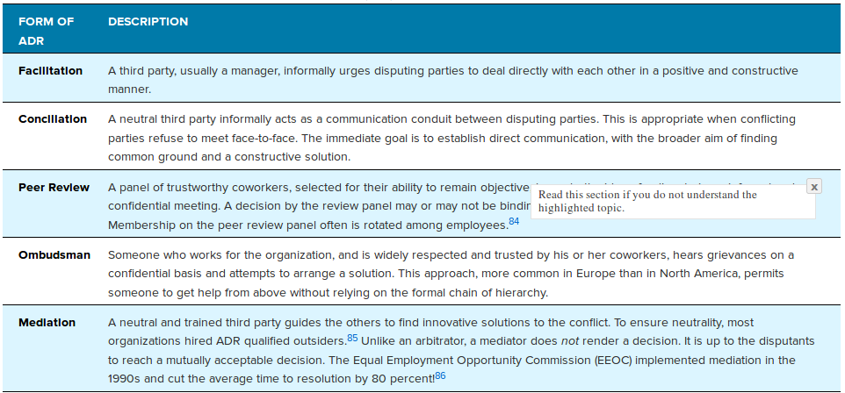

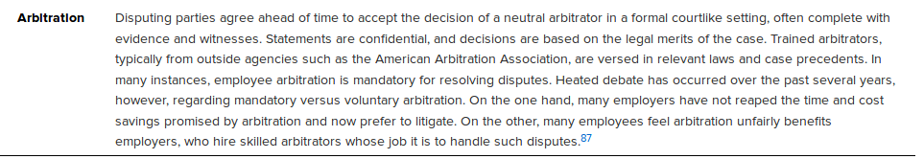

## 10.5 Negotiation,

MAJOR QUESTION

What are some best practices for effective negotiation?

The Bigger Picture,

Life is an endless series of negotiations. It therefore is valuable to better understand negotiation and related strategies. We discuss different forms and tactics of negotiation in this section because they are both the cause and remedy of many conflicts.

Negotiation is a give and take decision making process between two or more parties with different preferences. A common example is labor management negotiations over wages, hours, and working conditions. Negotiation is even more important today given the increasingly complex and competitive workplace. More personally, you’ll negotiate many job salaries and promotions and other factors related to your own jobs and career. And you’ll be expected to accomplish more things, in more places, with more people, which increases the value of your negotiation skills.

Two Basic Types of Negotiation,

Negotiation experts often distinguish between two fundamental types of negotiation, ‘position-based or distributive, and interest-based or integrative. Understanding the difference has great practical value.

Position Based vs. Interest Based,

A distributive negotiation usually concerns a single issue, a, fixed pie, in which one person gains at the expense of another. This win lose approach is arguably the most common type of negotiation and is characterized by dividing up the pieces of a pie. There is only so much pie to go around, and two or more parties negotiate over who gets how much or which parts. Haggling over the price of a car is a position based or distributive negotiation. You have a particular price you want, and you get it only if the seller compromises on the price he or she desires.

However, many conflicts bring together a variety of interests not just the price of a car, and each party in the negotiation values those interests differently. The outcome is no longer a fixed pie distributed among all parties. Instead, a host of interests are integrated into a mutually satisfying solution. Such scenarios call for integrative negotiation, in which a host of interests are considered, resulting in an agreement that is satisfactory for both parties. This kind of interest based negotiation is a more collaborative, problem solving approach. As one group of researchers puts it, instead of dividing a pie, as in position based negotiation, interest based negotiations often generate win win outcomes, one party gets the crusts and the other the fruit the part each prefers . Interest based negotiations may even lead to creative solutions. The parties may decide to build a pie factory together instead of negotiating over individual pies.

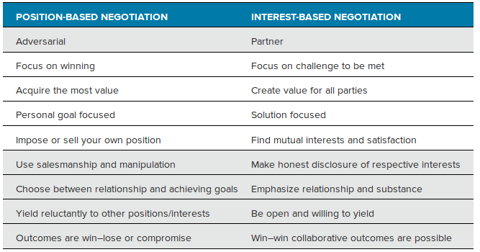

Applying a Collaborative Interest-Based Approach,

The collaborative, interest-based approach is explicitly based on problem solving, and it can be applied between two or more individuals, between an individual and a group, or between two or more groups. The following protocol is followed by renowned negotiator Christina Merchant.

1. Define and frame the issue in terms of parties’ interests.
2. Explain the respective interests listen, learn, and share.
3. Explore expanding the pie create value rather than claiming it.
4. Create options.
5. Evaluate options in light of the interest described in step 1.
6. Choose the option that best meets the interest described.
7. Develop and agree on a plan of implementation.

Factors to Consider in All Negotiations,

Regardless of your negotiation approach, finding areas of common ground can be difficult. Successful negotiators are able to weigh multiple issues and gather information about which are most important to the other parties and why. Research and practice provide some helpful hints:

Know who you are. Personality matters. Research shows that people with high levels of agreeableness are best suited for integrative negotiations, whereas those low in this personality characteristic are better at distributive negotiations. Why do you think this is?

Manage outcome expectations. In most negotiations, each party has an expected outcome and compares it to the actual outcome. Skilled negotiators manage expectations in advance of actual negotiations. For example, if two people paid $35,000 for a car, then the one who expected to pay $33,000 was disappointed and the one who expected to pay $37,000 was delighted. Similarly, managers will often send out a message saying, It’s been a tough year, in advance of annual reviews and salary discussions.

Consider the other person’s outcome. Of course you negotiate for your own benefit. But it also matters how the other party fares, is he or she satisfied?

Adhere to standards of justice. Not only do the outcomes need to be perceived as fair distributive justice , but so too do the processes by which they were attained. For instance, nobody likes to be taken advantage of, such as by having incomplete information. Again, think of buying a new car. The dealer knows all the numbers, and despite the best information the web has to offer, you are still never as well informed.

Remember your reputation. You may, win, today, only to foreclose opportunities in the future. Put another way, winning at all costs often has significant costs!

Emotions and Negotiations,

Many people believe good negotiators show no emotion, like Roger Federer on the tennis court. But as you’ve learned, emotions are an integral part of the human experience and of almost everything we do. Negotiation experts and researchers acknowledge this and provide guidance on how to use emotions to your advantage. Remember that emotions are contagious. If you want the other party to be calm, creative, or energetic, consider showing these emotions yourself.

OB in Action,

Take It from an FBI International Hostage Negotiator

Negotiating a pay raise or the price of a new car is stressful. But if you had Christopher Voss’s former job, you would be negotiating on behalf of the FBI for the safe return of hostages in many of the most unstable, war-torn parts of the world. That is an entirely different type of stress. Voss is therefore eminently qualified to teach us all something special about effective negotiations. He offers the following advice:

1. Be likable! People are six times more likely to make a deal with someone they like.
2. Confirm your understanding. Ask questions of the other side to be sure your perceptions of their position are accurate.
3. Let the other side go first. Regardless of how important the outcome is to you, you’ll benefit from learning the other parties’ interests. What is their position? What do they want? What challenges do they see? You’ll never have all the facts, but do what you can to learn what you can early in the process.
4. Don’t make too much of body language. Look for all nonverbal cues, such as tone and volume of voice and facial expressions; sometimes they are quite telling. But don’t rush to conclude that folded arms or crossed legs mean resistance.
5. Mind your emotions. Anger most often generates resistance and defensiveness, which never help your cause. Anger can be used strategically, but beware of it and of other unintended and unproductive emotions.
6. Be ready to say, that doesn’t work for me. It is important to be willing to say no and walk away. Just be sure to do it gracefully; you don’t want to burn bridges unnecessarily. Says Voss, if you’re not willing to say no, you’ve taken yourself hostage.

Preparation is critical to effective negotiations. The following tips can help you prepare emotionally for an upcoming negotiation.

1. Identify your ideal emotions. How do you want to feel going into the negotiation? Why? Many people answer this question quickly and say, Calm but assertive, but when probed further they reveal other, if not competing, emotions. The challenge is to realize which emotions will best suit your objectives, and be mindful of them while negotiating.
2. Manage your emotions. What can you do in advance to put yourself in the ideal emotional state? Promote positive emotions. Choose appropriately, meditation to calm you down or perhaps music that pumps you up. If you are ambushed or put on the spot, such as by an unexpected phone call or somebody stopping by your office, buy some time and say to your negotiating partner, I just need to wrap up what I’m doing, and I’ll call you back in 10 minutes., This will give you time to regain the appropriate emotional state.
3. Know your hot buttons. What can throw you off balance? Some people seem eternally patient, while others get frustrated easily. And some negotiators try to push your hot buttons as a deliberate tactic. Know your own tendencies and be sure to manage them appropriately.
4. Keep your balance. Everyone loses balance once in a while. How will you regain it if lost? Taking a break is a good idea. Stepping out, going to the restroom, or simply calling a, time out, can provide a break in the action and enable you to regroup. These same tactics can redirect a negotiation that has gone in the wrong direction. You also may want to redirect to higher level issues, especially if you are getting bogged down in details.
5. Identify your take away emotions. How do you want to feel when you’re finished? Many people say, Relieved, which signifies the stress many of us feel while negotiating. Others say, Satisfied, which speaks more to performance. Whatever the case for you, set goals for emotions just as you do for other outcomes in negotiations and in the Organizing Framework.

Ethics and Negotiations,

The success of negotiations is often influenced to a large extent by the quality of information exchanged. Telling lies, hiding key facts, and engaging in other potentially unethical tactics erodes trust and goodwill, both of which are vital in successful negotiations. Awareness of these dirty tricks can keep good faith bargainers from being unfairly exploited. See Table 10.9 for a list and description of unethical negotiating tactics. These behaviors also need to be factored into organizational codes of ethics, and every employee from the top to the bottom of the organization must adhere to them.

